**Tutorial 5**

**Question 1: Trees**

For each of the following trees, fill in its corresponding three tables:

* The first table is about generic properties of the tree.
* The second table is about properties for specific nodes in the tree.
* The third table contains an array. For each node in the tree, you should mark which position in the array it should occupy.

**Tree 1**

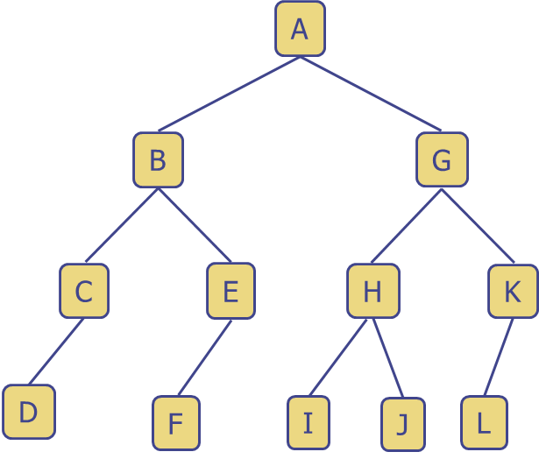

|  |  |  |  |
| --- | --- | --- | --- |
| Property | | Answer | |
| Root Node | |  | |
| Internal Nodes | |  | |
| External Nodes | |  | |
| Height of tree | |  | |
| Inorder traversal | |  | |
| Preorder traversal | |  | |
| Postorder traversal | |  | |
|  | **Depth** | | **Ancestor** | | **Descendants** |
| **A** |  | |  | |  |
| **B** |  | |  | |  |
| **C** |  | |  | |  |
| **D** |  | |  | |  |
| **E** |  | |  | |  |
| **F** |  | |  | |  |
| **G** |  | |  | |  |
| **H** |  | |  | |  |
| **I** |  | |  | |  |
| **J** |  | |  | |  |
| **K** |  | |  | |  |
| **L** |  | |  | |  |

|  |  |  |  |  |  |  |  |  |  |  |  |  |  |  |  |
| --- | --- | --- | --- | --- | --- | --- | --- | --- | --- | --- | --- | --- | --- | --- | --- |
| **0** | **1** | **2** | **3** | **4** | **5** | **6** | **7** | **8** | **9** | **10** | **11** | **12** | **13** | **14** | **15** |
| **-** |  |  |  |  |  |  |  |  |  |  |  |  |  |  |  |

**Tree 2**

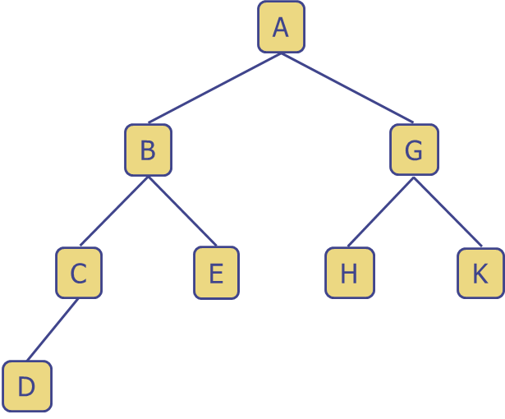

|  |  |  |  |
| --- | --- | --- | --- |
| Property | | Answer | |
| Root Node | |  | |
| Internal Nodes | |  | |
| External Nodes | |  | |
| Height of tree | |  | |
| Inorder traversal | |  | |
| Preorder traversal | |  | |
| Postorder traversal | |  | |
|  | **Depth** | | **Ancestor** | | **Descendants** |
| **A** |  | |  | |  |
| **B** |  | |  | |  |
| **C** |  | |  | |  |
| **D** |  | |  | |  |
| **E** |  | |  | |  |
| **G** |  | |  | |  |
| **H** |  | |  | |  |
| **K** |  | |  | |  |

|  |  |  |  |  |  |  |  |  |  |  |  |  |  |  |  |
| --- | --- | --- | --- | --- | --- | --- | --- | --- | --- | --- | --- | --- | --- | --- | --- |
| **0** | **1** | **2** | **3** | **4** | **5** | **6** | **7** | **8** | **9** | **10** | **11** | **12** | **13** | **14** | **15** |
| **-** |  |  |  |  |  |  |  |  |  |  |  |  |  |  |  |

**Tree 3**

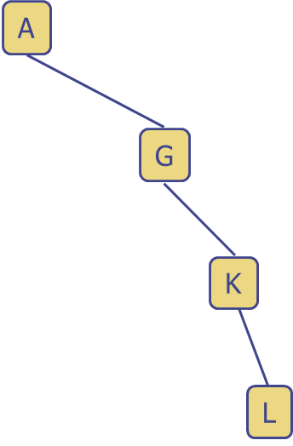

|  |  |  |  |
| --- | --- | --- | --- |
| Property | | Answer | |
| Root Node | |  | |
| Internal Nodes | |  | |
| External Nodes | |  | |
| Height of tree | |  | |
| Inorder traversal | |  | |
| Preorder traversal | |  | |
| Postorder traversal | |  | |
|  | **Depth** | | **Ancestor** | | **Descendants** |
| **A** |  | |  | |  |
| **G** |  | |  | |  |
| **K** |  | |  | |  |
| **L** |  | |  | |  |

|  |  |  |  |  |  |  |  |  |  |  |  |  |  |  |  |
| --- | --- | --- | --- | --- | --- | --- | --- | --- | --- | --- | --- | --- | --- | --- | --- |
| **0** | **1** | **2** | **3** | **4** | **5** | **6** | **7** | **8** | **9** | **10** | **11** | **12** | **13** | **14** | **15** |
| **-** |  |  |  |  |  |  |  |  |  |  |  |  |  |  |  |

**Tree 4**

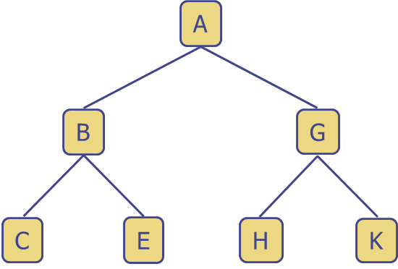

|  |  |  |  |
| --- | --- | --- | --- |
| Property | | Answer | |
| Root Node | |  | |
| Internal Nodes | |  | |
| External Nodes | |  | |
| Height of tree | |  | |
| Inorder traversal | |  | |
| Preorder traversal | |  | |
| Postorder traversal | |  | |
|  | **Depth** | | **Ancestor** | | **Descendants** |
| **A** |  | |  | |  |
| **B** |  | |  | |  |
| **C** |  | |  | |  |
| **E** |  | |  | |  |
| **G** |  | |  | |  |
| **H** |  | |  | |  |
| **K** |  | |  | |  |

|  |  |  |  |  |  |  |  |
| --- | --- | --- | --- | --- | --- | --- | --- |
| **0** | **1** | **2** | **3** | **4** | **5** | **6** | **7** |
| **-** |  |  |  |  |  |  |  |

**Tree 5**

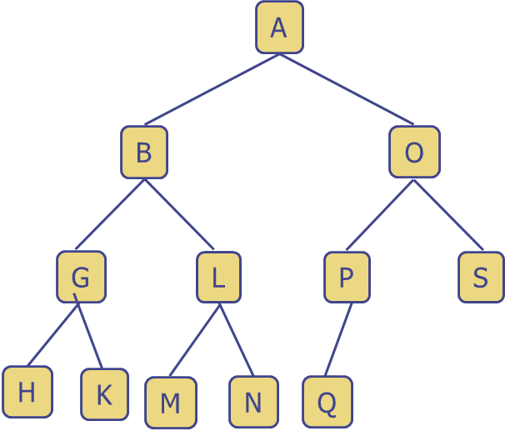

|  |  |  |  |
| --- | --- | --- | --- |
| Property | | Answer | |
| Root Node | |  | |
| Internal Nodes | |  | |
| External Nodes | |  | |
| Height of tree | |  | |
| Inorder traversal | |  | |
| Preorder traversal | |  | |
| Postorder traversal | |  | |
|  | **Depth** | | **Ancestor** | | **Descendants** |
| **A** |  | |  | |  |
| **B** |  | |  | |  |
| **G** |  | |  | |  |
| **H** |  | |  | |  |
| **K** |  | |  | |  |
| **L** |  | |  | |  |
| **M** |  | |  | |  |
| **N** |  | |  | |  |
| **O** |  | |  | |  |
| **P** |  | |  | |  |
| **Q** |  | |  | |  |
| **S** |  | |  | |  |

|  |  |  |  |  |  |  |  |  |  |  |  |  |  |  |  |
| --- | --- | --- | --- | --- | --- | --- | --- | --- | --- | --- | --- | --- | --- | --- | --- |
| **0** | **1** | **2** | **3** | **4** | **5** | **6** | **7** | **8** | **9** | **10** | **11** | **12** | **13** | **14** | **15** |
| **-** |  |  |  |  |  |  |  |  |  |  |  |  |  |  |  |

Additional questions:

1. Which of the above trees, if any, are proper binary trees?
2. How big of an array do we need to store an arbitrary binary tree of height *h*?
3. We have shown how to use an array representation for binary trees. How would we extend this to work on ternary trees?